# ATTACHMENT A. CODING MANUAL

## 1. Manual Objective

The Research Center for Safe and Secure Society, Nagaoka University of Technology (NUT) is working in collaboration with the Digital Human Research Center (currently the Artificial Intelligence Research Center, or AIRC), National Institute of Advanced Industrial Science and Technology (AIST) to conduct research and development on “An Evidence Information Base for Advanced Risk Management in Living Spaces”; this project was selected to receive a research grant in FY2014 by the Research Institute of Science and Technology for Society (RISTEX), Japan Science and Technology Agency (JST). By linking known injury information with data on the various types of risks associated with living spaces, this project aims to establish a consolidated information base to facilitate the extraction of risk-related information, as well as to develop methodologies for the utilization of this information base in risk management.

The objective of this manual is to explain the framework for describing known injury information, as well as to specify unified coding criteria for the reorganization of data from existing injury information databanks.

The initial version of the manual was published in March 2015, and this second version includes various additions and improvements. As research and development efforts progress, further additions and improvements will be made as required.

Detailed descriptions of examples where this manual was utilized will be included in the final version of the manual.

## 2. Approach to the Injury Information Description Framework

According to the World Health Organization (WHO), an injury refers to the physical damage that results when a human body is suddenly or briefly subjected to intolerable levels of energy by an agent, which can include mechanical energy, heat, electricity, chemicals, and ionizing radiation. In this definition, there are four elements in the occurrence of an injury: the host (i.e., the person who is injured), the agent (i.e., the force, energy, or chemical that causes the injury), the vector (i.e., the person or thing that applies the force, transfers the energy, and causes the injury), and the environment (i.e., the situation or conditions under which the injury occurs). While the epidemiological model proposed by the WHO comprises these four elements, the outcomes of an accident (degree of injury) are important for determining the relative priority of countermeasures. Different accident outcomes require correspondingly different countermeasures, and the responses will vary depending on whether an accident results in fatalities, severe injuries, or light injuries. As a consequence, this manual proposes the **Injury Information Description Framework** (IIDF) as a description framework for injury information databanks. The IIDF comprises five elements, with the addition of an accident’s “consequence” to the four elements of the WHO epidemiological model. In order to establish this description framework, it is necessary to characterize each element in the conceptual model and to define the vocabulary set used to describe each of these attributes. This content is provided in Table 1.

### (1) Host

The host refers to the person who has sustained an injury. The injury information system does not require the inclusion of personally identifiable information. In fact, the inclusion of information that could potentially identify individuals would limit the range of injury information that can be provided. However, attribute information such as age may be needed for investigations into the causes of accidents and the review of possible countermeasures. In ISO 12100:2010 *Safety of machinery -- General principles for design -- Risk assessment and risk reduction*, Chapter 5.3.2 (Use Limits) states that risk assessments should take into consideration the full utilization range of machinery (e.g., industrial, non-industrial, and domestic) by persons identified by sex, age, dominant hand usage, and limiting physical abilities (visual or hearing impairment, size, strength, etc.). Accordingly, information on the sex, age, and limiting physical abilities of each host are required items for risk assessment in our framework.

The ISO/IEC Guide 50:2014 *Safety aspects -- Guidelines for child safety in standards and other specifications* states the need to consider the cognitive and motor development of children when evaluating risks. In particular, children aged 1–2 years have under-developed cognitive abilities, and their motor skills can change on a daily basis. Therefore, it is ideal for age to be provided in units of months for hosts aged below two years.

Furthermore, some injuries may be concentrated in specific geographical regions. As a result, the region where an accident occurred should be included as a basic item. Cultural differences among ethnic groups can also give rise to disparities in awareness and perceptions. Therefore, each host’s race, region, and nationality should also be included as required items in injury information.

### (2) Vector

The vector—which is the cause of an injury—is not limited to a product, but can also include other entities such as persons, plants, and animals. This manual describes “initiating vectors” (causes of the injury), “intermediate vectors” (associated with the accident, but are not the main cause), and “direct vectors” (directly related to the injury). While the initiating vector may also be the direct vector in some cases, these vectors are distinct in other cases. It is critical to include information on the origin and condition of the initiating vector and the cause and responsibility of the direct vector in this injury information system. It would also be beneficial to include information on the model and unit type of products, associated businesses (including manufacturers, importers, and retailers), and utilization duration prior to accident, as these can inform the risk assessment process.

### (3) Agent

An agent can refer to a mechanical force or energy that induces a result, as well as an element in a mechanism that causes injury to a person. This manual proposes the description of agents using the following four items: hazard source (e.g., mechanical or thermal source of hazard), mechanism (e.g., falls, impact with an object, and contusions), cause of injury (e.g., design flaw, time-related deterioration, and improper use), and presence/absence of fire. As the effects of fires are far-reaching, it was determined that fire-related agents should be addressed separately.

With regard to the mechanism of accident occurrence, we predict that the standard descriptive vocabulary lists are insufficient in cases involving complicated injuries or novel accidents. The system should therefore allow the inclusion of relatively free descriptions to supplement the characterization of mechanisms in such cases. To this end, the system will include an “accident summary” item in the remarks column to allow unstructured descriptions.

In this description framework, injuries are categorized into one of two classifications from the WHO Family of International Classifications (WHO-FIC): the International Classification of Diseases and Related Health Problems (ICD) and the International Classification of External Causes of Injury (ICECI). ICD is already used in a variety of applications in Japan, ranging from population vital statistics to medical statistics. In contrast, the ICECI has yet to be widely implemented in applications throughout the world. However, as the name indicates, this classification system was designed specifically for injuries, and a short list has been developed to facilitate its use in the US Centers for Disease Control and Prevention (CDC). The ICECI is expected to be employed in a wider set of applications in the future, and was therefore included in this system. As there is no official Japanese translation currently available, we have independently worked on its translation for our purposes.

As classifications are based solely on the ICD and ICECI, there are many cases that will not be indicated in a complete coding system. It should therefore be noted that the codes provided in this manual are independently assigned by the manual’s authors.

### (4) Environment

An injury environment is composed of factors such as the time of injury, place of injury, and the injured person’s actions at the time that the injury occurred. The classifications of traffic accidents and occupational accidents define injuries according to the actions of the injured person at the place or time of the injury. In other words, the classification of injuries uses environment-related information that is extracted from available injury information. This is also applicable to other types of accidents, such as medical accidents and school accidents.

In this manual, information on injury environment is categorized into either natural environment factors or artificial environment factors. Natural environment factors include four items: date of injury, time of injury, weather conditions, and natural disasters; artificial environment factors include eight items: action classification, place of injury, utilization frequency of the initiating vector, location of the initiating vector, implementation of safeguards, stage of utilization, product condition at the time of occurrence, and residential environment. The first four items address natural environment factors such as date and time, weather, and natural diseases; the latter eight items are artificial environment factors that describe the actions of the injured person at the time of the injury, the place, and the initiating vector. Social environment factors, such as the watchfulness of guardians, may also affect the occurrence of injuries.

### (5) Consequence

Information on consequences is obtained from the severity of injuries borne by the host and the extent of damage to objects. Information on the extent of harm is crucial for determining the priority of accident countermeasures, and is also a necessary element for evaluating the magnitude of risks. In order to prevent accidents, actions that utilize the investigation status and official announcements of measures are valuable resources for societal risk management. In this research, information on consequences will include the following six basic items: extent of harm (injury severity and extent of damage), injured body part, type of injury (e.g., burn, poisoning, and fracture), treatment classification (e.g., no treatment, additional treatment, and hospitalization), number of injured persons, and implementation of countermeasures.

### (6) Remarks

In order to manage the accident information, remarks on the following seven types of information will also be included: ID number, date of report, information source, investigation status, clarification of the accident cause, recall date, and accident details (unstructured description).

## 3. Injury Occurrence Model and Injury Information Attributes

A wide variety of injuries occur in everyday life, and these are caused by a multitude of intricately intertwined elements. Accordingly, there is a need to allow the systematic description of these conditions. As stated earlier, this manual specifies a description framework involving five elements based on the WHO epidemiological model. However, the epidemiological model is unable to clarify the unsafe behavior (if any) of the injured person, which would constitute a causal factor of the injury. To resolve this issue, the second version of the manual includes an expansion to allow the precise description of human behavior that could be a hazard source with reference to *Roudousaigai Bunrui no Tebiki* (A Guide to Occupational Accident Classification; Published 19xx) by XX. This guidedescribes both the **unsafe behavior** of the injured person and the **unsafe situation** of the thing/object as causes of injuries. As a result, an attribute was also included to allow the precise description of the host (one of the five elements) as a possible hazard source. Therefore, “human action” is provided as an attribute alongside the hazard source under descriptions of the agent (Refer to Figure 1).

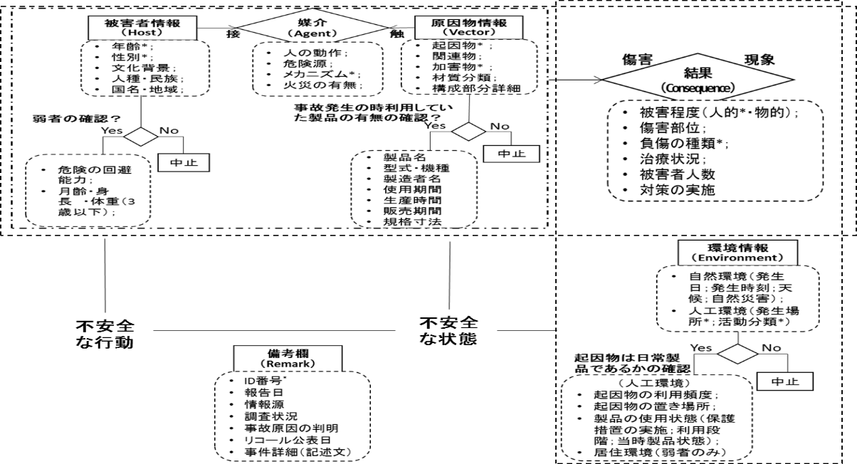

**Figure 1. Injury occurrence model and injury information attributes**

(Note: * denotes attributes that are essential items used in international statistical standards, such as those used by the WHO; the other items are optional.)

## 4. Initiating Vectors, Intermediate Vectors, and Direct Vectors

The second version of the manual includes substantial revisions to the description method for initiating vectors, intermediate vectors, and direct vectors. The process of injury occurrence can involve a large number of factors, such as the product being used, the influence of the surrounding environment, factors that directly harm the injured person, or human actions that were the trigger for accidents. In accordance with the WHO’s ICECI, this second version of the manual classifies vectors into initiating, intermediate, and direct vectors. Information on each of these attributes should be included in the framework.

In order to provide specific examples of the items described in the preceding paragraph and Figure 2, unstructured descriptive sentences from the items of “accident notification content” and “accident cause” in the National Institute of Technology and Evaluation (NITE) database were reorganized using the framework conceptualized in this manual. The results are shown below.

（事例1）：**年度番号**：2008-1150；　**品名**：いす（乳幼児用）

**「事故通知内容」**：乳幼児用ローチェアのテーブルを後方にした状態で，１才の子供が使用中，いすが後

**起因物1　　　　　　　　　　　　　　　　　　　年齢　　　　利用段階**

方に倒れ，テーブル裏面の端　で　眉間　を　切った．

**メカニズム１　　　加害物　　　　傷害部位　　傷害タイプ**

**「事項原因」**：保護者が目を離した時に　子供　がいすの座面上に立ち上がり，背もたれ部分に寄りかかっ

**関連物1　保護者の動作　起因物2　　　危険源　被害者の動作　関連物2**

たため，背もたれ方向に力が加わり，いすと共に後方に転倒しものと推定される．

**メカニズム2**

（事例2）：**年度番号**：2007-5545；　**品名**：電気ストーブ

**「事故通知内容」**：木造２階建て集合住宅の　一室　から　出火　して，同室の壁や天井の一部を焼き，

**材料　　　　居住形式　　関連物　　危険源　　　　危害の程度（物の損害）**

家人１人　が　全身　　　火傷　　で病院に搬送されたが，その後死亡した．

**被害者員数　傷害部位　負傷の種類　治療分類　　　　　　　被害の程度**

**「事故原因」**：使用していた　　電気ストーブ　に被害者の着衣　が　　接触　・　着火し，

**利用段階　　　　　起因物1**　　　　**起因物2　メカニズム　 加害物**

火災に至ったものと推定される．

**事故原因の判明**

As indicated above, when codifying injury information based on the ICECI, descriptions of the two attributes of “mechanism” and “object/substance” were categorized into three stages: Initiating (involved at the start of the **injury event**) → Intermediate (involved in the injury event) → Direct (producing the actual physical harm).

In order to explain this description method from a different angle, we can use a two-dimensional matrix involving the ICECI’s three stages of injury processes (Initiating, Intermediate, and Direct) and the NITE database’s damage classifications (No damage, Object damage, and Injury). Here, the “object” is the key, and we use three examples of baby carriage accidents selected from the NITE database (shown in Fig. 3). Through the establishment of databases that include incidents without damage and accidents with damage to objects and property (but no injuries to humans), we may be able to elucidate the reasons that explain how an incident progressed to an accident. This will provide highly important evidence for advanced product safety management and the actualization of risk management.

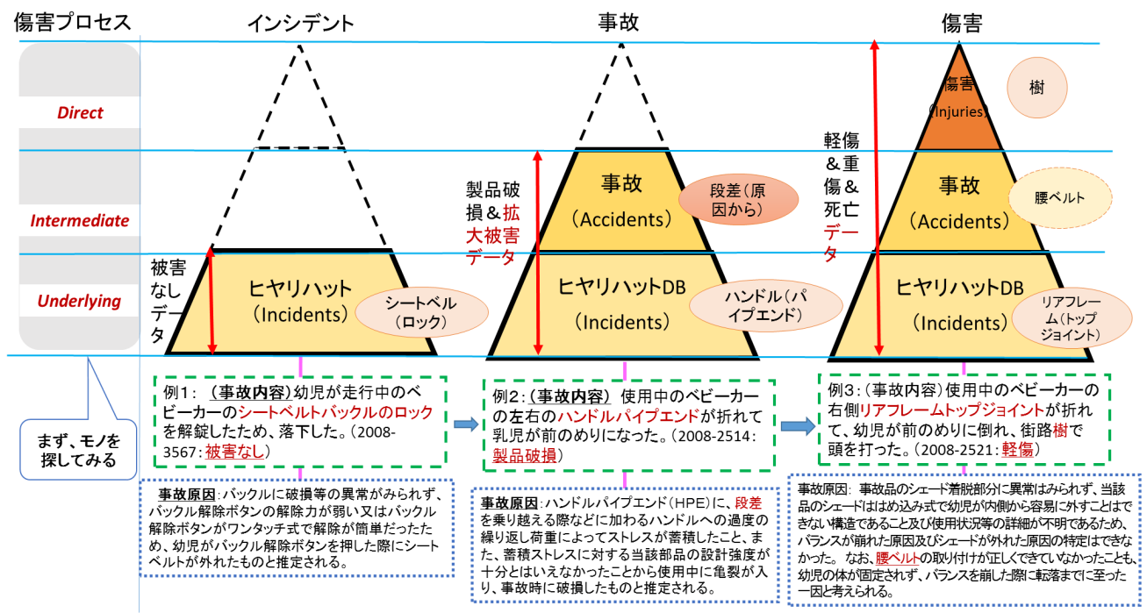

**Figure 2. Examples of applications of injury information reorganization using NITE data**

Although there are existing information databases concerning injuries in daily life in various fields, the lack of a unified format in data entry means that even if there is valuable information stored in these databases, it may not always be possible to adequately re-utilize this information to benefit society. This manual uses the IIDF format to consolidate and summarize the injury information databases currently managed by various government ministries and agencies within Japan. In this way, we provide a novel approach for the future development of new technology to utilize injury information.

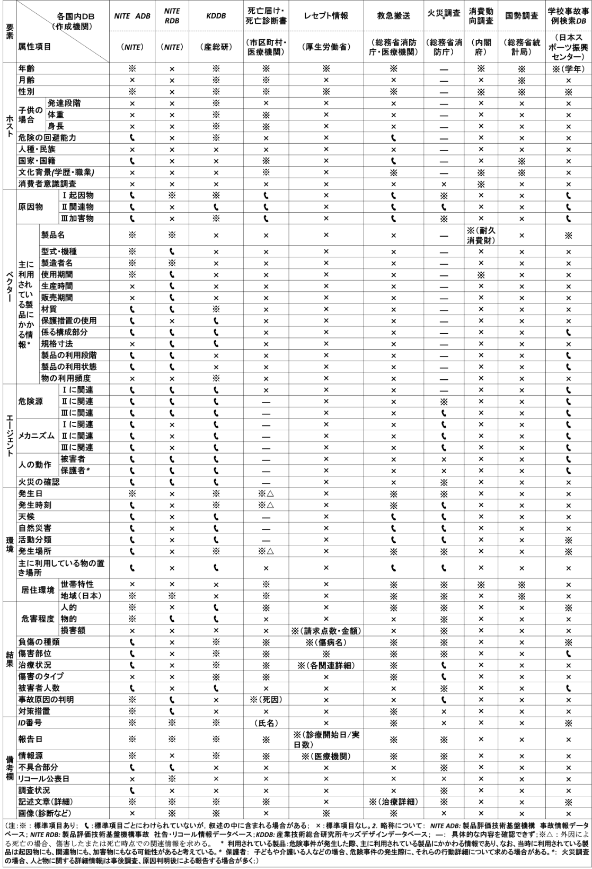**Table 1. Organization of recorded items in various domestic databases concerning risk information in living spaces based on the** **Injury Information Description Framework (IIDF)**

## 5. Information Sources of the Standardized Vocabulary List

Standardizing and codifying information enables us to maximize the use of injury information. Accordingly, this manual uses, where possible, vocabulary lists that comply with international standards (e.g., WHO and ISO) and domestic standards for the individual items presented in Figure 2. However, there is currently a lack of international standards for several attributes that are thought to be required for the elucidation of injuries and the improvement of product design. As a result, we have independently developed classification codes for these attributes.

**Table 2. Information sources of the standardized vocabulary list used in the IIDF**

|  |  |
| --- | --- |
| **レベル** | **標準名** |
| **国際** | * ISO3166-1国名コード * GS1コード； * ICECI　（WHO　The International Classification of External Causes of Injury）； * HS コード（Harmonized Commodity Description and Coding System） * JICFS　製品分類コード * ISO14121 Safety of machinery -- Risk assessment * ICD-10　（WHO The International Classification of Diseases ） * DENVERⅡ：Denver Developmental Screening Test |
| **国内**  **地域** | * EU-RAPEX Guideline 2010 * 日本標準地域コード * 日本標準職業分類 * 大気現象記号表（日本） * 災害対策基本法2条1号（日本） * 製品安全に関する事業者ハンドブック（日本） |
| **組織** | * NITE（製品評価技術基盤機構）分類 |
| **独自** | * 統合的な危険源リスト   （RAPEX/ISO12100/ISO14141/Guide50/Guide71/ISO10377/ISO10393/NITE事故事例/NUREGを統合したもの）   * 統合的な負傷の種類リスト（ICD-10/NEISS/EU・IDB/RAPEXを統合したもの） * 統合的な治療分類リスト（NEISS/EU・IDB/RAPEXを統合したもの） * 材質語彙セット * 構成部分の語彙セット * 人間動作語彙セット * 家庭構造および内部詳細語彙セット * 世帯属性語彙セット |

## 6. Manual Characteristics

Through the development of the aforementioned designs, the injury data in this manual exhibit the following distinctive characteristics:

* Enable international comparisons;
* Reduce operation time for data mining;
* Enable objective and quantitative risk assessments;
* Reduce costs through the integrated management of various data;
* Improve convenience for all users through the use of logical hierarchical data expressions;
* Form the foundation of public-private shared information exchange.

## 7. Manual Authors

While this manual incorporates the results of various projects conducted by research group members from NUT and AIST, authorship of this manual centered around Dr. Kun Zhang (a member of the AIST’s AIRC and a research fellow [JSPS Postdoctoral Fellow] at NUT’s Research Center for Safe and Secure Society) and Prof. Yoshiki Mikami, Principal Investigator. The standardized vocabulary list was independently developed by Mr. Yuki Iizawa, Ms. Junko Sato, and Ms. Yukari Yokota. Mr. Yuki Iizawa organized the printed materials.

The integrated hazard source list attached to the Appendix was developed by Prof. Takabumi Fukuda and Mr. Yuki Iizawa from the Department of System Safety, NUT, as part of a research project funded by a Grant-in-Aid for Scientific Research entitled “Surveillance of Injury Information in the Era of Market Surveillance” (FY2013 to FY2015; Principal Investigator: Prof. Yoshiki Mikami).

# ATTACHMENT B. INJURY PYRAMID OF JAPAN

## 1. How Injured do Japanese People Get?

Just how injured do Japanese people get throughout the course of a year? Also, what is the breakdown of the causes and severity of these injuries? Despite the relative simplicity of these questions, they are not easy to answer.

The answers to these questions can be found in the Patient Survey conducted by Japan’s Ministry of Health, Labour and Welfare. This survey, which is conducted once every three years, aims to “investigate the actual situation of diseases and injuries of the patients who use hospitals and clinics (hereafter, medical institutions) to obtain basic data for the promotion of medical and health services”. At the point of writing this manual (March 2016), the most recent Patient Survey was conducted in 2014, with previous surveys conducted in 2011, 2008, 2005, 2002, 1999, and so on.

There are more than 13,000 hospitals and XXX clinics located throughout Japan, but only approximately XX% are included in the survey. In the 2011 survey, all 6,428 hospitals and 5,738 clinics (corresponding to XX% of all clinics; excluding dental clinics) were included in analysis. All of the medical institutions surveyed would record and report on the numbers of inpatients and outpatients, as well as the medical care provided to these patients on a specified date in October of the survey year.

Details on injuries are examined based on the World Health Organization’s International Classification of Diseases and Related Health Problems (ICD). Information on injuries is provided in Chapter XIX of this classification system entitled “Injury, poisoning and certain other consequences of external causes”. These include injuries due to traffic accidents, occupational accidents, and accidents that occur at home or at school.

According to the 2011 Patient Survey, an estimated 124,800 inpatients and 317,600 outpatients were treated at hospitals and clinics. Both of these estimates were obtained from a single day. The Patient Survey also provides estimates on the total number of patients by calculating the “estimated number of patients who were continuously receiving medical treatment (including those who did not receive medical treatment at medical institutions on the dates of this survey)” as follows:

Estimated number of inpatients + Estimated number of initial-visit outpatients + [Estimated number of return-visit outpatients × Average interval since last visit × Adjustment factor (6/7)]

This estimation formula (especially the third component) may be slightly difficult to understand, and is explained further for clarity below. Although outpatients generally make multiple visits to medical institutions, let us assume an average interval of one month (30 days) between outpatient visits. Among the patients who are continuously receiving medical treatment during the survey period, there will be return-visit outpatients who were scheduled to visit on the date of the survey as well as return-visit outpatients who are scheduled to visit on other days. To estimate the total number of return-visit outpatients, the estimated number of return-visit outpatients can be multiplied by the average interval between visits (30 days). This is also multiplied by the adjustment factor (6/7) in order to account for the days without return-visit outpatients, such as Sundays and other holidays.

By summarizing the above survey results, the estimated number of patients classified as having “Injury, poisoning, and certain other consequences of external causes” can be calculated, which are presented in Table 1.

Table 1. Estimated number of inpatients, outpatients, medical consultation rate, and total number of patients with injuries, poisoning, and certain other consequences of external causes

|  |  |  |  |  |  |
| --- | --- | --- | --- | --- | --- |
|  | 0～14歳 | 15～34歳 | 35～64歳 | 65歳以上 | 合計 |
| 推定入院患者数（千人） | 1.5 | 6.1 | 22.6 | 94.2 | 124.8 |
| 推定外来患者数（千人） | 45.4 | 54.6 | 119.3 | 96.5 | 317.6 |
| 人口（千人） | 16,705 | 27,757 | 53,579 | 29,173 | 125,525 |
| 入院受診率（10万人対） |  |  |  |  |  |
| 外来受診率（10万人対） |  |  |  |  |  |

出典：患者調査（平成23年度）

## 2. Annual Incidence of New Injuries

Readers should note that the survey results presented above represent the values from a single day. As the survey aims to provide basic data for the promotion of medical and health services, it is important to be aware of issues such as whether a hospital has sufficient beds or if the physician-patient ratio is appropriate; this explains the need for information on daily patient numbers.

However, this information does not answer the question of how often the average Japanese person is injured in a year. The majority of injury data appearing in this manual provide annual figures, and it is therefore necessary to estimate the annual incidence of new injuries based on the data above. Consequently, there is a need to process these data before they can be used.

To calculate the annual number of inpatients, we can assume that the number of hospitalized patients on the date of the survey is the same throughout the year. Accordingly, the number of patients who are continuously receiving treatment can be calculated by multiplying the number of inpatients on the survey date by 365, and dividing the result by the average length of hospital stay. Fortunately, the survey also records the average length of hospital stay for patients who were discharged in the month preceding the survey date, which can be used in the above calculation. The results of this calculation are presented below in Table 2.

Table 2. Annual incidence of new injuries according to age

|  |  |  |  |  |  |
| --- | --- | --- | --- | --- | --- |
|  | 0～14歳 | 15～34歳 | 35～64歳 | 65歳以上 | 合計 |
| 推定入院患者数（千人） | 1.5 | 6.1 | 22.6 | 94.2 | 124.8 |
| 平均在院日数（日） | 5.9 | 12.6 | 21.6 | 46.7 | 33.4 |
| 年間入院患者数（千人） | 92.8 | 176.7 | 381.9 | 736.3 | 1387.7 |
| 人口（千人） | 16,705 | 27,757 | 53,579 | 29,173 | 125,525 |
| 年間入院率 | 0.0056 | 0.0064 | 0.0071 | 0.0252 | 0.0111 |

Elderly persons aged 65 years or older account for more than half of inpatients. In contrast, the calculation of outpatients presents more problems. If we estimate the annual number of outpatients by multiplying the number of outpatients on the survey date by 365 (370,000 outpatients/day × 365 days = 135,050,000), the resulting number would exceed the total population of Japan. This is because the number includes multiple visits by the same patients. How many times, on average, would an outpatient visit a hospital? This number cannot be derived from the published results of the Patient Survey. However, the survey provides data separately for initial-visit outpatients and return-visit outpatients. These data can be used to estimate the average number of outpatient visits using the following formula, which can subsequently be used to calculate the annual number of outpatients.

Average number of outpatient visits = (Estimated number of initial-visit outpatients + Estimated number of return-visit outpatients) ÷ Estimated number of initial-visit outpatients

According to the Patient Survey, outpatients visited medical institutions an average of 5 times for injuries, poisoning, and certain other consequences of external causes. The total annual numbers of outpatients who visit medical institutions according to age are presented below in Table 3.

Table 3. Annual numbers of outpatients who visit medical institutions according to age

|  |  |  |  |  |  |
| --- | --- | --- | --- | --- | --- |
|  | 0～14歳 | 15～34歳 | 35～64歳 | 65歳以上 | 合計 |
| 推定外来患者数（千人） | 45.4 | 54.6 | 119.3 | 96.5 | 317.6 |
| 平均外来回数（回） |  |  |  |  | 5 |
| 年間外来患者数（千人） |  |  |  |  | 23,185 |

To summarize, there are approximately 1.38 million inpatients and 23.19 million outpatients who are treated annually for injuries, poisoning, and certain other consequences of external causes. We obtain a total of 24.57 million patients annually, which gives a proportion of 0.19 (24.57 million/125.53 million) of Japan’s population. This indicates that one out of every five Japanese people will be treated (either as an inpatient or outpatient) for injuries, poisoning, and certain other consequences of external causes every year.

This number is much higher than expected from our actual experience with everyday life. It is possible that the estimated number includes patients who have changed medical institution halfway through treatment, or those that simultaneously receive treatment at multiple institutions. The actual ratio of injury-related fatalities to injury-related outpatients in Europe is estimated to be 1:150; if we apply this to Japan’s data, we get a ratio of 1:700. Due to a current lack of data to clarify the actual conditions, we are unable to extrapolate these figures any further.

Supposing that these figures are accurate, the probability that no one in a family of four would be treated at a hospital for an injury in a year can be calculated as (1-0.19)4, or approximately 43%. Conversely, the probability that someone in that family of four would be treated at a hospital for an injury in a year can be calculated as 1-(1-0.19)4, or approximately 57%

However, this probability is highly dependent on the age structure of the family. As shown in Tables 2 and 3, elderly persons are more likely to be hospitalized or treated as outpatients. Therefore, the inclusion of elderly persons raises the probability of being injured and requiring treatment.

In Table 4, we present the results of the probabilities of receiving treatment as inpatients or outpatients for members of various typical family units.

Table 4. Probability of receiving treatment as inpatients or outpatients for members of typical family units

|  |  |  |  |  |
| --- | --- | --- | --- | --- |
| 家族構成 | 若者単独世帯  15歳～34歳 | 四人の核家族  夫婦64歳以下  子供14歳以下 | 夫婦と高齢者  夫婦64歳以下  同居65歳以上 | 高齢者のみの夫婦世帯 |
| 一年間に家族全員が入院も通院もしない | 計算中 |  |  |  |
| 一年間に誰かが通院を要する傷害を負う |  |  |  |  |
| 一年間に誰かが入院を要する傷害を負う |  |  |  |  |

## 3. Number of Fatalities Due to Injuries

On the other hand, just how many fatalities are there due to injuries, poisoning, and certain other consequences of external causes? We can use population vital statistics to address this question. In the survey results from 2011, the number of accidental deaths was found to be 33,510.

## 4. Injury Pyramid

Based on the above data, we can construct the following injury pyramid of Japan.

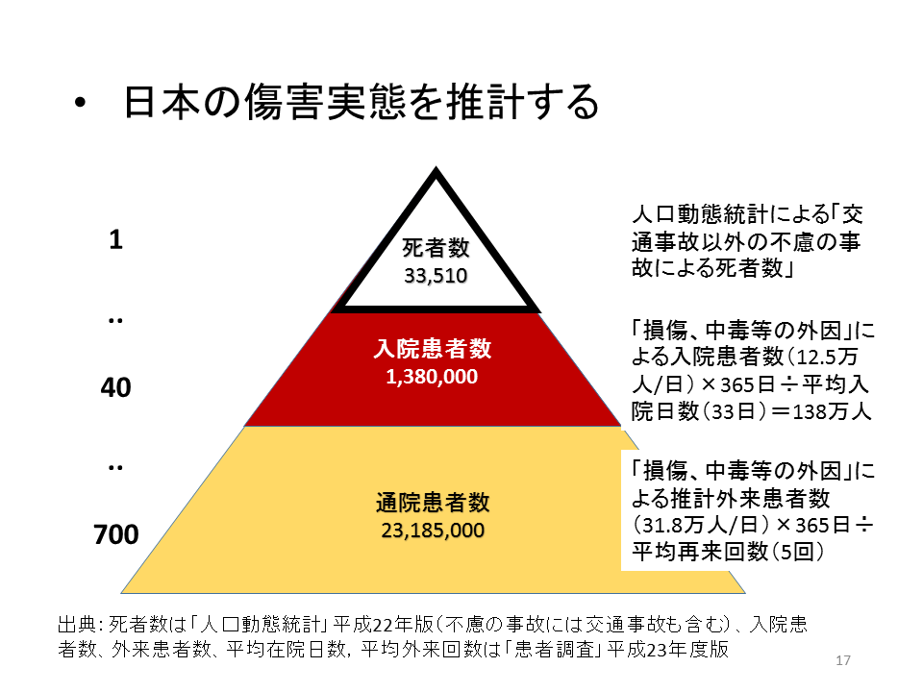

Reference: Injury Pyramid of the European Union

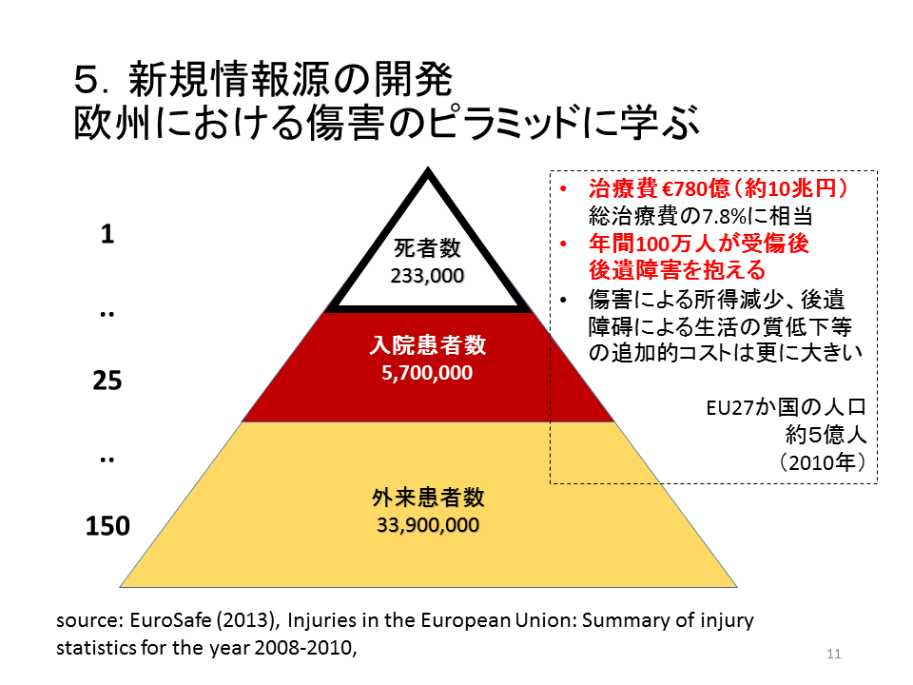

# ATTACHMENT C. PAPERS

査読論文

* 巴図孟克,張坤,福田隆文,三上喜貴, 製品事故データベースと消費動向調査を利用した製品事故率の経年変化の把握, 日本信頼性学会誌Vol.37, No.4(通巻224号), P191-200, 2015.
* K.Zhang, J. X .Wang, T.Fukuda, Y.Mikami, Descriptive framework of injury data: a proposal based on a Japanese experience of injury database integration [J]. Journal of Risk Research, 2017, 20 (1):85-98
* Mengke Batu, Y.Mikami, Feature Analysis of the Actual Use of Household Electrical Appliances in an Aging Society : A Case of Japan, International Journal of Consumer Policy 5, pp.1-12, 2015.

総説等

* 三上喜貴・張坤，安全安心社会研究センターの研究プロジェクト紹介～生活空間の高度リスクマネジメントのためのエビデンス情報基盤構築～，安全安心社会研究第６号，2016年3月
* 張坤, 中国における運輸事業の交通事故調査について, 安全安心社会研究第６号，2016年3月

口頭発表

* 西田佳史，日常生活の科学に基づく傷害予防工学～安全知識循環エコシステムの共創～，長岡技術科学大学・明治大学共催システム安全特別講演会，2015年7月5日，明治大学紫紺館．
* Y.Mikami, Safety Design in the Age of Anthropocene, The 9th International Symposium on Advances in Technology Education, Hotel New Otani Nagaoka, 2015 September 16.
* P.Jiang, K.Zhang, Y.Mikami, The Analysis of Product Recall Delay based on NITE Database, 第48回安全工学研究発表会, 朱鷺メッセ，2015年12月3-4日．
* 岡本満喜子・中平勝子・三上喜貴，製品事故情報に基づく高齢者のヒューマンエ ラー特性の抽出，ヒューマンインターフェース学会第130回研究発表会，2016年3月28日，京都工芸繊維大学松ヶ崎キャンパス
* Y.Mikami, Le Thi Quynh Lien, Artifacts as threats to mankind in the perspective of the Anthropocene, KAHAKU Meeting for the Study of the history of Technology, 2015 March 11, National Museum of Science and Nature, Tsukuba
* 嵩下孟，北村光司，西田佳史，溝口博, "介護タスク構造を考慮した介護施設のリスク状況予測法," 第16回SICEシステムインテグレーション講演会(SI2015), pp.0076-0079, 2015
* 三上喜貴，第27回鉄道総研講演会，平成26年11月12日，招待講演「安全マネジメントの歴史に学ぶ」
* 三上喜貴，経済産業省主催「製品安全に係る人材育成研修」における総括講演，平成27年3月3日，「製品安全を担う人材として求められる役割」
* Mikami, Y., Evaluating Risk of Unfinished Recalls, Society for Risk Analysis (SRA)，Denver Colorado, USA, 2014/12/17
* Kun ZHANG, Yoshifumi Nishida, Yoshiki Mikami, Development of a Coding Manual for Describing Risk Information to Integrate Product Accident Databases in Japan, 2016 International Symposium on Safety Science and Technology (ISSST), Wenhui Hotel, Kunming, Yunnan Province, China, October 17-19, 2016.
* Kun Zhang, Shidong Mei, Guoxun Jing, Yoshifumi Nishida, Yoshiki Mikami, Text Data Analysis of Severe Road Traffic Accidents in China, 2016 International Symposium on Safety Science and Technology (ISSST),, Wenhui Hotel, Kunming, Yunnan Province, China, October 17-19, 2016.
* Jingsheng Liu, Kun Zhang, Yoshiki Mikami, Development of an integrated hazard vocabulary set for toy recall text mining, 2016 International Symposium on Safety Science and Technology (ISSST), Wenhui Hotel, Kunming, Yunnan Province, China, October 17-19, 2016.

ポスター発表

* Zhang, K. & Mikami, Y.，Multidimensional Injury Pattern Analysis: A Study of Children’s Product Injury in Japan，Society for Risk Analysis (SRA)，Denver Colorado, USA, 2014/12/17
* Y. Mikami, K.Zhang, Product Cohort Database and Its Application to Post-Recall Management, World Congress on Risk, Singapore, 2015 July 19-23.
* K. Zhang, Y.Mikami, A Generic Child Injury Data Framework for Kids Product Designers, World Congress on Risk, Singapore, 2015 July 19-23.
* Pei JIANG Kun ZHANG, Yoshiki MIKAMI, Comparative research on five product recall information system: China, U.S.A, EU, Japan and Australia, The 4th International GIGAKU Conference, Nagaoka, Japan, June, 2015.
* Kun ZHANG, Yoshifumi Nishida, Koji Kitamura, Yoshiki Mikami, Desing Ontology For Kids Design Database, Satety2016- the World Conference on Injury Prevention and Safety Promotion, World Health Organization, Finland, September 2016.
* Yoshiki MIKAMI, Kun ZHANG, Analysis Of Recall Behavior In Japanese Market, Satety2016- the World Conference on Injury Prevention and Safety Promotion, World Health Organization, Finland, September 2016.

# ATTACHMENT D. PRODUCT LIFE WG

## 1. Product Survival Rate, Product Life, and Residual Risk of Recall

As a form of data utilization technology, this project is examining the methods concerning the risk evaluation of unfinished recalls that both the government and business entities struggle with. We presented our findings on the estimation method of product survival rates (an important key to risk assessment of recalled products) at the Society for Risk Analysis Annual Meeting in 2014 in the US. Subsequent results were presented at the World Congress on Risk 2015, which was held in Singapore.

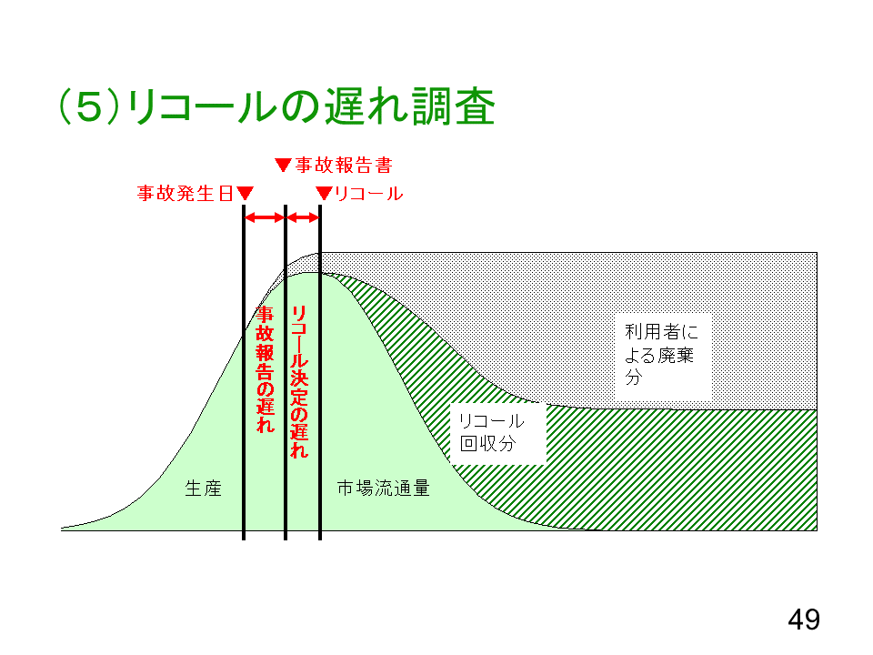

Figure. The recall process

If we are able to obtain the product survival curve r(t), the risk assessment of unfinished recall products can be performed using a relatively simple formula. In actual practice, the survival curves of individual products can be accumulated using this method, and widely provided as public data. This facilitates the simple risk assessment of unfinished recalled products, and it may be possible to conduct these analyses using an evidence base.

With regard to this theme, the research and development efforts conducted this year were further developed after becoming acquainted with new stakeholders; based on survival rate estimates, the research challenges expanded to include estimates of product life. These new stakeholders in question were Mr. Toshinori Watanabe and Mr. Toshiro Kikuchi, who are part of the Product Life Working Group (WG), which is an organization formed in 2011 comprising volunteer experts with an interest in industrial product safety issues (the chairperson is Dr. Masao Mukaidono, Professor Emeritus of Meiji University). This study’s principal investigator and colleagues had published a paper entitled *Characterization of Product Accident Rate based on Product Accident Database and Consumer Confidence Survey* (The Journal of Reliability Engineering Association of Japan), which was the product of a research topic supported by a Grant-in-Aid for Scientific Research and, in essence, the preliminary study for this current research. This paper drew the attention of Mr. Watanabe, who then contacted the principal investigator. Following several sessions of exchanging ideas, we were able to delve deeper into this research theme.

Over a span of approximately three years, this WG had (centering on 20 engineers in manufacturing companies working on product safety) conducted research on product life and how products break down. However, the lack of information on the number of surviving units in each product formed a bottleneck, and research activities were halted due to the inability to resolve this issue. During that period, our research team published the above paper, and the principal investigator was contacted; this effectively cleared the path that enabled us to estimate the number of surviving units in individual products. (Refer to Table 16)

Activities of the Product Life WG and exchange activities with this research project

|  |  |  |
| --- | --- | --- |
| 年 | 研究代表者の取り組み | 耐用寿命研究会 |
| 2007 | 内閣府に「消費動向調査第９表で平均使用年数が発表されていますが，平均値ではなく使用年数別の分布を求めることは可能でしょうか？」と問合せ．オーダーメード集計の存在を知る． |  |
| 2011 |  | 耐用寿命研究会発足 |
| 2012 | 統計センターにオーダーメード集計を依頼．再集計可能な範囲に限界があることがわかる． |  |
| 2013 | 7月　内閣府に統計法33条に基づく利用申請  11月　調査票データが届き，分析に着手． | 第二次耐用寿命研究会（5月～12月） |
| 2014 | JST/RSITEXプロジェクト採択 |  |
| 2015 | 7月　日本信頼性学会誌に「製品事故データベースと消費動向調査を利用した製品事故率の経年変化の把握」発表． | 渡部氏から左記論文ついて問い合わせ．年末から合同で勉強会を開催． |
| 2016 |  | 第1回傷害情報ワークショップで研究計画を発表． |

A new development is that with the use of our proposed method for estimating the number of surviving units, we were able to calculate the time-related changes in product accident rates. This facilitates the estimation of product life through implementation of the Weibull distribution analysis. While the provision of feedback on risk-related information to the producers and designers remains an important task of this project, the establishment of a methodology that approaches product life data from a macro perspective would provide an effective tool for designers.

Figure 14 illustrates the Weibull distribution developed through the meetings that have been conducted thus far. The Weibull distribution, which is a probability distribution function proposed by Waloddi Weibull in 1939 to statistically explain the strength of an object, is used to describe the degradation phenomenon over time and the object’s lifespan. The Weibull distribution is a probability distribution generally expressed by the following formula:

f(t) = $\frac{m}{η}{(\frac{t}{η})}^{m-1}exp\left\{{-\left(\frac{t}{η}\right)}^{m}\right\}$

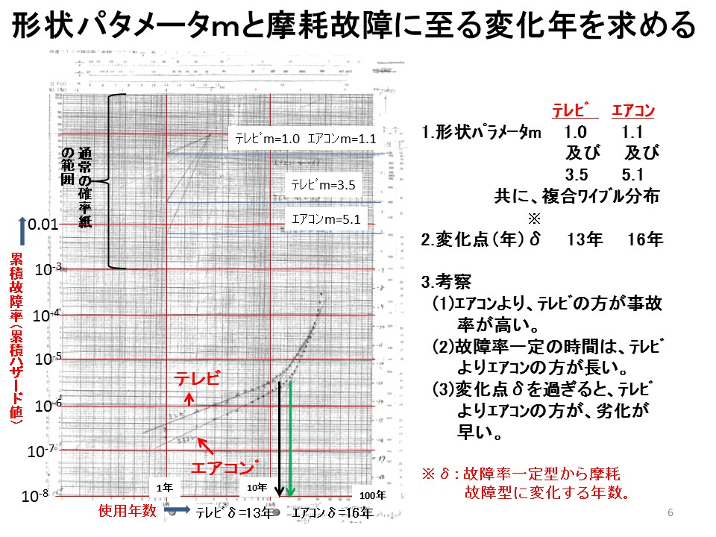

Figure. The Weibull curve for the accident rates of televisions and air-conditioners

Here, m refers to the Weibull coefficient or the geometric parameter, and η refers to the scale parameter. The Weibull distribution changes substantially with changes to the value of m. For example, the Weibull distribution is an exponential distribution when m = 1, but becomes a Rayleigh distribution when m = 2. In general, the failure phenomenon also changes with time, and can be classified into the three categories of initial-stage failure, accidental failure, and wear-out failure. When applying the Weibull distribution to the accident rate curve, it is able to accommodate m < 1 for initial-stage failures, m = 1 for accidental failures, and m > 1 for wear-out failures. The δ when accidental failures transition to wear-out failures is, essentially, product life. It would be of great interest to examine the product life (in years) of products that are actually in the market.

Figure 14 shows the results of actual television and air-conditioner accident rates that were fitted to the Weibull distribution using the method proposed in this study. This figure shows that δ is approximately 11 years for television and 13 years for air-conditioners. In the future, we wish to further improve upon this result and couple it to practical estimates of product life. A report in the previous year has shown that it is possible to use a simple formula in calculating the risks that recalled products remain in the market. The National Institute of Technology and Evaluation (NITE) product recall database indicates that there are approximately 1,800 incomplete recalls at present in Japan. The identification of the product with the highest risk from among all these recalled products is a major problem faced not only by the businesses involved, but also by the authorities. A key issue is that there are no reliable data on the quantity of recalled products that remain in the hands of consumers. Our proposed estimation method has provided insight on product life, which facilitates the acquisition of highly reliable evidence by the manufacturers and authorities.

# ATTACHMENT E. HISTORY OF INJURY INFORMATION ANALYSIS

## 1. Beginnings from Church-derived Big Data: Graunt’s Mortality Table

This project’s aim to build an evidence base is not a novel endeavor, even in the field of injury information. A long time ago, John Graunt (1620–1674) first explored demographic statistics based on church records of baptisms and burials. In the field of statistical history, he is regarded as the “founder of demography”, and may also be considered to be a pioneer in the field of injury data science. Graunt analyzed the number of burials during the 60-year period from 1604 to 1664, and constructed a table that categorized these deaths according to 81 different causes of death. However, the causes of death had been recorded by “uninformed persons in the role of coroner”, and therefore could not be effectively used. Despite this, Graunt was able to discern a form of regularity in the injury data, as he found that several of the causes of death maintained a fixed ratio with the total number of burials. He also constructed a table of casualties, and noted that similar phenomena could be observed in drowning, suicides, and various types of accidents in that there was a sense of regularity in accident-related deaths. His insight that it may be possible to observe a certain degree of regularity in injury occurrence through data analysis may be considered the dawn of injury data science. Furthermore, Graunt also conducted estimates on population vital statistics using what is known as a “life table”. Edmond Halley went on to refine this life table, which formed the mathematical basis of life insurance.

In the middle of the 19th century, approximately 200 years after Graunt’s era, several cities in Europe began conducting population surveys. As ever, the causes of death varied widely, which underscored the need to scientifically develop a universal classification of these causes. In this context, the International Classification of Diseases and Related Health Problems (ICD) was created. The development of this scientific classification system enabled, for the first time, the accurate extraction of information from raw data.

H. W. Heinrich (1886–1962), who is famous for his eponymous Heinrich’s Law, may be considered the one who established a new frontier on the quantitative evaluation of accidents. Heinrich was an engineer in the Travelers Insurance Company, and analyzed big data concerning insurance claims for industrial accidents. He also discovered several other empirical laws in addition to his famous 1:30:300 rule, and emphasized the importance of safety measures to management staff by enabling the visualization of industrial accidents. Since then, evidence data concerning industrial accidents and injuries have become an important policy tool for the labor bureaus of various countries, and have grown to be the foundation of industrial safety administration. The establishment of the International Labour Organization (ILO) has advanced the international standardization of data standards concerning industrial accidents, and enabled the development of industrial accident databases that allow for international comparisons.

## 2. The Evolution of the Epidemiological Approach: Snow, Nightingale, and Haddon

When England was gripped by a cholera outbreak in 1831, John Snow (1813–1858), a physician, focused on the relationship between the origin of infected patients and the position of a communal water well. Snow realized that the infection was not airborne, but instead spread through drinking water. As a result, effective measures to prevent the further spread of infection could be implemented.

Shortly after, Florence Nightingale (1820–1910) was a nurse at a hospital in Scutari, which was located at the frontline of the Crimean War. Nightingale perceived that the poor hygiene conditions at the field hospital were responsible for many of the soldiers’ deaths. She prepared mortality statistics at the field hospital, and used these as concrete evidence to protest against the stubborn army commander’s refusal to admit that the hospital was operating under terrible conditions. Nightingale’s proposed measures took immediate effect, and the soldiers’ mortality rates dropped rapidly.

The activities of Snow and Nightingale took place several decades before the discovery of various etiologic agents in succession by Robert Koch and others. In other words, these activities created viable measures based on data concerning the occurrence of diseases combined with environmental factors that preceded medical analyses of causal relationships. Thus, epidemiology was born.

In the field of medicine, elucidating the pathological causes of a disease is conducted in parallel with examining the epidemiological causes of disease. William Haddon (1926–1985), an engineer in the US National Highway Safety Agency, demonstrated that it was possible to adopt an epidemiological approach to identify causes in the elucidation of accident occurrence processes in addition to examining the engineering and human factors. The surge in traffic accidents in the 1960s had become a massive societal problem in the US. To address this problem, Haddon formulated what is now known as the “Haddon Matrix”, which is a framework that enables the comprehensive assessment of traffic accidents and strategies for intervention. This matrix is an epidemiological framework that facilitates an extensive review of accident occurrences, where the vertical rows represent the timeline (pre-accident, accident occurrence, and post-accident) and the horizontal columns represent various factors that contributed to an accident (human factors, vehicle and equipment factors, and environmental factors). Based on this framework, Haddon proposed various measures—such as the use of seatbelts—that have been effective in reducing injuries. He presented startling data on the probabilities of being involved in a traffic accident throughout the life cycle of an automobile, where 1 out of 30 cars would have an accident resulting in bodily harm, and 1 out of 5 cars would have an accident resulting in harm to a passenger. This called attention to the importance of crash safety design. This information was presented at a combined meeting between the Texas branch of the Society of Automotive Engineers (SAE) and the regional medical society. Despite the lack of graphs and figures, the persuasiveness of the report lay in the provision of actual numbers for key points that highlighted the need for improvements in the automobiles themselves. While epidemiological frameworks had been previously limited to diseases and public health, Haddon expanded their application to accidents, and these were later adopted by the World Health Organization.

## 3. A Nationwide Injury Surveillance Net Built by the US

During the 17th century when Graunt lived, people only had records of baptisms and deaths. However, those of us who live in today’s society are subject to a wide variety of records, including accidents and injuries. Through the application of these records, we are able to obtain highly accurate information on the occurrence of injuries in everyday life.

The US experienced a high number of accidents due to defective products in the 1960s. In response to this situation, the Consumer Product Safety Act was rapidly developed and enacted. This act stipulated the initiation of the National Electronic Injury Surveillance System (NEISS), which was designed to systematically obtain information not only on industrial and traffic accidents, but also on accidents that occur in living spaces (at home, at leisure, at school, etc.). Based on rigorous statistical sample design from approximately 6,000 emergency care hospitals located nationwide, a sample of 130 hospitals was selected; injury data and analysis were then initiated based on a coding manual. (Incidentally, US government statistics are almost entirely based on statistical inference, and rely little on descriptive statistics involving the entire population. This is in marked contrast to Japan, which favors surveys that use complete enumeration.)

At present, the system collects information on approximately 370,000 injuries per year, which indicates that 13,000,000 injuries occur annually when extrapolated to all hospitals in the US. An official of the Consumer Product Safety Commission estimated there to be a total of approximately 34,000,000 injuries when accounting for the injuries not treated at hospitals. These data are available online for download and analysis. While the number of recorded items is limited, the data can be analyzed as big data due to the codification of information such as age, sex, location of accident, type of treatment, injured body part, and category of the product that caused the accident. Other databases include the Injury and Potential Injury Incident (IPII) database, which contains near miss information (approximately 30,000 cases per year); the Death Certificates (DTHS) database, which includes information on fatalities due to products (approximately 8,000 cases per year); and the 4-stage In-Depth Investigation (INDP) database (approximately 8,000 cases per year).

## 4. The Drive to Share Injury Information Across Borders in Europe

The integration of markets in Europe in 1985 advanced efforts among countries to collaborate and share injury information. Previously, each country had its own surveillance system for traffic, industrial, and living space accidents. These systems were integrated, and all injury information was consolidated as big data. In the European Union (EU), the Rapid Exchange of Information System (RAPEX) is an emergency alert system for product recalls. This system enables the sharing of information throughout the EU, where information on a high-risk product identified in one region can be transmitted to the rest of the union.

## 5. The World’s Factory: China’s Injury Information System Attracts Wide Interest

In today’s society, a large proportion of daily products (such as textiles, toys, commodities, and home appliances) used throughout the world are manufactured in China. The lifestyles of the world’s consumers are, to a large degree, dependent on Chinese products. Some time back, the book *A Year Without "Made in China"* was a bestseller in the US, and the author concluded that living without Chinese products was prohibitively difficult. In this context, global consumers have great interest in the question, “Just how safe are Chinese products?”

Authorities responsible for consumer product safety in Japan, the US, and Europe have collaborated with China’s General Administration of Quality Supervision, Inspection and Quarantine to establish a feedback channel for product recall information to Chinese manufacturers concerning their products in overseas markets. It is hoped that this will function as an incentive for improvements.

In addition, consumers within China are also increasingly concerned about product safety, with calls for manufacturers and authorities to also focus on domestic consumers. In response, the government implemented the National Injury Surveillance System (NISS) in 2007 to collect injury information from throughout the country. Similar to the US and EU, the information collection channel is composed of emergency care hospitals. While information had been gathered from 22 hospitals located throughout 18 provinces until 2013, the number of hospitals has currently increased to 54. Although information on 50,000 product-related injury cases has been gathered, the use of these data is limited and not available to all users.

## 6. An Amalgam of Diverse Information: Japan’s Injury Information System

While the previous examples of injury information systems from other countries were based mainly on information from emergency care hospitals, the system in Japan is substantially different from those of the US and Europe in that it uses a wide variety of information sources, such as businesses, consumers, consumer affairs centers, hospitals, and newspaper articles. Since the 1970s, several injury information systems have been developed in Japan, including the National Consumer Affairs Center of Japan’s PIO-NET (information sources include consumer complaint information and hospitals) and the product accident information database of the National Institute of Technology and Evaluation (NITE; information sources include reports from businesses). With the inauguration of Japan’s Consumer Affairs Agency in 2009, the various injury information systems were consolidated under this agency’s accident information databank system. As this system was not established in accordance with a single coordinated design principle, there are variations in the recorded items and classifications. Therefore, while it may be described as unified, this database is, in fact, an amalgam that lacks systematicity. The systems in the US and Europe involve data input at a location (i.e., hospitals) distant from where the accidents occurred, but Japan’s information sources tend to be nearer the accident location, which enables relatively detailed descriptions of the accidents. In addition, the NITE database has the exceptional practice of conducting verification experiment operations.

Under the serious accident reporting system implemented in 2007, businesses are mandated to report serious accidents (such as fatalities, accidents resulting in serious injuries, and fires) to the Consumer Affairs Agency. Despite this mandate, the number of accidents reported to the Consumer Affairs Agency has remained at approximately 20,000 cases per year, which is thought to cover only a portion of all accidents that occur in Japan. The US NEISS receives 370,000 reports per year, and uses sampling design to estimate the total number of accidents throughout the country. In contrast, the data in Japan are not collected based on scientific sampling methods, and therefore cannot be used to produce national estimates.

For the same reason, it is unclear if the aggregate results according to age groups and location are indicative of overall trends. The following is an international comparison of these estimates from claims data.

|  |  |  |  |  |
| --- | --- | --- | --- | --- |
|  | 米国 | ＥＵ | 中国 | 日本 |
| 名称 | 電子傷害サーベイランスシステム（NEISS） | 傷害データベース（IDB） | 国家製品傷害情報システム(NISS) | 事故情報データバンクシステム |
| 作成機関 | 消費製品安全委  CSPC | ＥＵ本部  DG-SANCO | 国家質検総局欠陥製品管理センター（DPAC）＆国家疾病予防センター（NCNCD） | 消費者庁 |
| 情報源 | 救急病院 | 救急病院 | 指名された病院 | 各種 |
| アクセス可能な年間データ件数 | 30-40万件 |  |  | 数２万件／年 |
| 収録開始年 |  |  | 2007年  試運用開始 | 2009年9月  登録開始 |
| 主要な記載情報 |  |  |  |  |

## 7. Japan’s Buried Big Data on Injury Information

There is a large amount of big data on injury information that remains dormant and unused in Japan. For example, ambulances are dispatched approximately 6 million times (in 2014) per year; of those, approximately 1.6 million of those dispatches involve patients with injuries or poisoning victims. The condition of each transported patient is recorded by the paramedics, who also receive recorded feedback concerning the patients’ diagnoses and treatments from the hospitals. Some of this information has been digitized and consolidated by the Fire and Disaster Management Agency (FDMA). Next, approximately 60,000 fires are reported each year. After each fire has been contained, an on-site investigation of the cause is conducted; the results are recorded in the detailed fire investigation report. Also, there are approximately 1 million traffic accident reports filed by police stations annually. Information on medical treatments for injuries and poisoning are recorded on patient charts in both outpatients and inpatients. In addition, detailed information in insurance claims data are also recorded. There is a massive amount of such information, with approximately 600 million cases of injured or poisoned patients alone each year. In cases when injuries or poisoning lead to fatalities, physicians must fill in a death certificate and submit a notice of death to the appropriate municipal government. The annual number of these cases exceeds 40–50,000 (Accidental deaths, 2014).

Statistical data based on these records are reported in white papers or annual reports by the FDMA and the police, or as part of population vital statistics. Although FMDA or police white papers include various analyses conducted based on these accident records, the individual records are not released for analysis, and remain dormant within the files and computers of these government agencies.

|  |  |  |  |  |
| --- | --- | --- | --- | --- |
|  | 死亡届 | 火災調査報告 | 救急搬送記録 | レセプト情報  入院・通院記録 |
| 作成者 | 親族→自治体 | 消防署 | 消防署 |  |
| 年間データ件数 | ４－５万件  〔外傷・中毒によるもののみ〕 | 年間6万件 | 160万件  〔外傷・中毒によるもののみ。病気を含めると600万件〕 | 6億件  〔医科合計。外傷・中毒関係は25%程度か？〕 |
| 電子化の有無と対外提供の可否 | ほぼ電子化されている〔厚労省保健情報部への聞き取り。統計法33条による個票提供の可能性あり〕 | 主要項目は電子化して消防庁に報告しているが、それ以外は各消防署内でペーパーベースで保存しているところが多いものと思われる。〔長岡消防署での聞き取り〕 | 同左 | 病院は99%以上電子化済み。NDBとして個票利用（サンプル抽出・匿名処理済み）促進のための窓口も設けられている。 |
| 主な記載項目 | 氏名  性別  生年月日  死因（ICD10） | 火災種別  出火日時  覚知・鎮火時刻出火場所住所  事業所名・業態  建物の構造等  原因・発火源  焼損状況  焼損棟数  死傷者数  死傷原因  り災世帯・人員  損害額  気象状況  防火管理の状況 | 搬送日時  搬送者氏名  性別  生年月日  措置内容  等 | 氏名（対外提供はハッシュID）  性別・年齢  都道府県コード  治療内容コード  傷病名コード  医療機関名  保険点数等 |